**📝 Flash Storage & Security Design**

**1. Key Hierarchy & Root of Trust**

* **DMS (Device Master Secret)**: one-time provisioned, never leaves device. Burned at provisioning.
* **KEK (Key Encryption Key)**: derived from DMS + boot counter + device UID. Used to wrap DEKs.
* **DEK (Data Encryption Key)**: per-record. Derived via HKDF. Used to encrypt record payloads.
* **KEK_ODD**: session-limited KEK derived after PIN/UV success. Used for records that require user presence/verification.
* **Session tokens**: short-lived, kept in RAM only, never persisted.
* **PIN stretching**: Argon2id (software) → stretched key → input to KEK_ODD derivation.
* **All derivations**: HKDF-SHA256 (CC310-backed).

**2. Record Format**

Each record = append-only unit in data segment.

* **Header**
  + Record UUID (random 128b)
  + Sequential number (monotonic, prevents replay/reinsertion)
  + Length (payload size)
  + Flags (alive/dead, type, etc.)
* **Body**
  + Encrypted payload (AEAD: AES-256-GCM, 96b nonce, 128b tag)
* **Trailer**
  + CRC32 (fast fail detection, optional)
  + AEAD authentication tag (mandatory integrity)

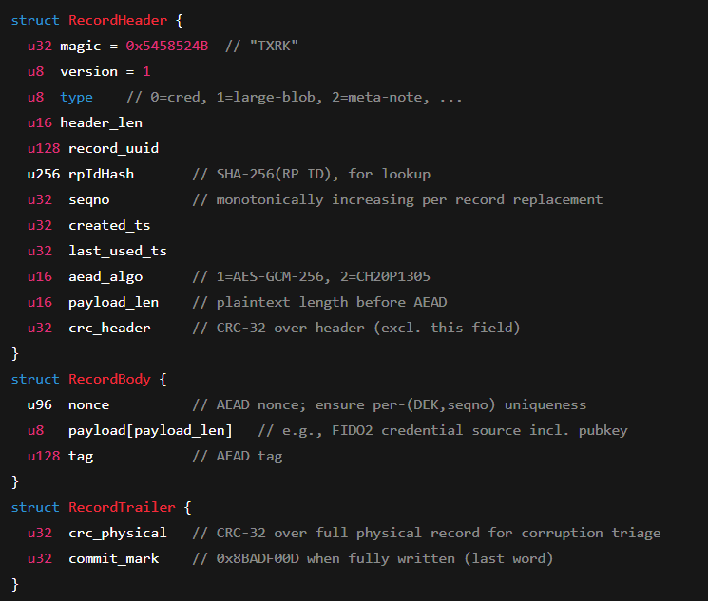

**3. Log-Structured Layout (Flash Partitioning)**

Fixed layout for **8 MB serial NOR flash (**Append-only, no in-place updates):

* **Superblock (metadata)** → 2 × 128 KB = 256 KB
* **Index region** → 256 KB
* **Data segment** → 6 MB (~5000 records @ 1.2 KB avg size)
* **Large blob area** → 1.5 MB (for CTAP2 largeBlob storage)

**4. Indexing & Lookup**

* Index maps UUID → physical location in data segment.
* Stored in fixed index region.
* Supports fast lookup & GC scan.
* Metadata confidentiality: index stores only hashes of user handles/PII.

**5. Anti-Rollback & Replay Protection**

* **Boot counter (monotonic)**
  + Increment on each successful boot.
  + One-way increment → stored in OTP or protected flash.
  + Used in KEK derivation → rollback makes KEK mismatch → old data undecryptable.
* **Superblock hash chain**
  + Hash = SHA256(prev superblock || boot counter || layout metadata).
  + Ensures continuity across reboots → tamper-evident.
* **Record sequential number**
  + Each UUID increments seq# on update.
  + Prevents replay of old record with same UUID.
  + Checked during lookup.

**6. PIN / User Verification Binding & Rate Limiting**

* After PIN/UV success: derive **KEK_ODD**.
* Store only a short-lived **ODD session token in RAM**.
* Encrypt UV-bound records with DEKs derived from KEK_ODD → useless without fresh verification.
* **Rate limit counters & back-off values**
  + Stored as small meta-records in flash.
  + Increment on failed PIN attempts.
  + Enforce exponential backoff (delay grows per failure).
  + Written with same commit protocol → atomic.

**7. Garbage Collection**

* Append-only writes → dead/stale records accumulate.
* GC process:
  1. Select segment for reclaim.
  2. Copy live records to new space.
  3. Erase segment.
* Trigger when free segments drop below threshold.
* Fragmentation handled automatically (copy compacts records).

**8. Crypto Modes, Parameters, Randomness**

* **AEAD**: AES-256-GCM (primary).
* **Nonces**: 96-bit, from TRNG (CC310).
* **KDFs**: HKDF-SHA256 (hardware), Argon2id (software, PIN only).
* **Integrity**: AEAD tags mandatory; CRC32 optional fast-fail.

**9. Power Loss & Crash Consistency**

* All mutating ops (writes, updates, deletes) = **two-phase commit**:
  + **Prepare**: write new record(s) as append.
  + **Publish**: atomically mark new record as live + old as dead.
* If crash before publish → old record still valid.
* If crash after publish → new record valid, old dead.
* Ensures no half-written corruption.

**10. Boot & Provisioning Checklist**

Step-by-step burn-in flow:

1. **Entropy check**: verify CC310 RNG working.
2. **Generate DMS**: 256b random, store in OTP/protected flash.
3. **Derive KEK** = HKDF(DMS || UID || boot counter).
4. **Provision root keys**: wrap and store securely.
5. **Initialize superblocks**: write SB0 + SB1 with clean layout + hash chain base.
6. **Initialize index region**: empty.
7. **Reserve GC space**: mark one free segment.
8. **Lock debug interface**.
9. **PIN provisioning**: store Argon2id-stretched key record.
10. **Initialize rate-limit counters** (0 attempts).
11. **First-boot test**: ensure KEK re-derivation, rollback check, GC run.

**11. Performance & Wear**

* Must always keep ≥1 free segment → GC breathing room.
* If data segment fills (6 MB used):
  + GC runs to reclaim space.
  + If no dead space left → out-of-storage error → reject new record.
* ~5000 records @ 1.2 KB average. Likely sufficient for FIDO2 credentials (tens to hundreds per user, not thousands).
* **QSPI-XIP**:
  + Quad-SPI Execute-in-Place → allows direct mapped read from flash → speeds lookups & index reads.
  + No need to copy into RAM for reads.

**12. Security Hardening Extras**

* **Metadata confidentiality**: never store raw user handles/PII. Only hashed IDs.
* **Side-channel hygiene**:
  + Zeroize secrets and buffers.
  + Use constant-time memcmp, memcpy.
  + Avoid secret-dependent branching.
  + Keep sensitive ops inside CC310 hardware.
* **Firmware-level hardening**: disable debug, lock fuses, enforce secure boot.

**13. Practical FIDO2 Fields Stored**

* Resident keys (RKs).
* User handles (hashed only).
* LargeBlob extension data.
* PIN-stretched key material.
* Rate-limit counters.
* Superblock + index metadata.